IFG Explore 2nd Year

Term One Weeks Two To Four Safe Az - Water Physical
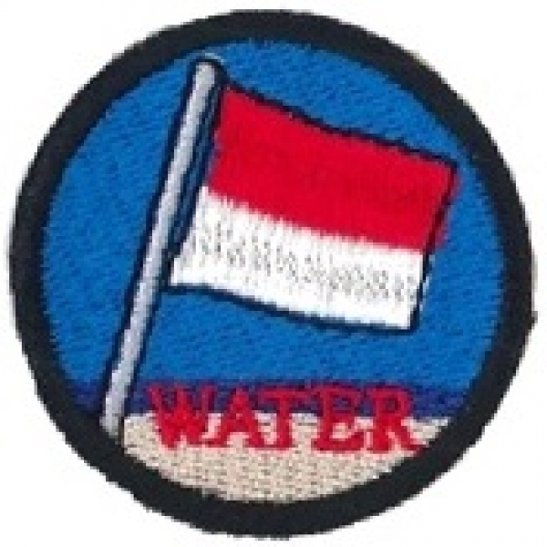

Aim: To teach the girls basic Water Safety skills and to be safe near water

Objectives:
On the Website: www.watersafety.org.nz there is a complete programme under the Water Wise Education tab. If you use the Year 1 and 2 programme all the resources are there for you, or you could use a qualified instructor to take the sessions.

This learning programme focuses on the key message: When we are in, on, or near water we need an adult to watch us.
Be Water Wise – be safe near water focuses on safety during school learn to swim programmes, at home and at rivers, beaches and public swimming pools. Activities are focused around the use of photographs and an A3 Picture Book Pippa and Paul playing safely in the water.

Preparation:
As the sessions are likely to be at a pool/beach or river you will need to gain parental permission and have extra adult supervision for the activities.
Transport to and from the venue will need to be organised ahead of time.

SetUp:
Commence the formal part of the evening with roll call etc.

Devotions:
Because of the type of activity there probably will not be time for a full devotion. Suggest a prayer before the activity starts.

Activity Session Teaching/Activity Session
Will be decided by team either using an instructor or using the Water Wise resources

Notices and Home Time:

